# Firewatch

Campo Santo (2016) *Firewatch*. [Video game]. Panic. Available from: <https://www.xbox.com/en-gb/games/store/firewatch/bqqkg9h2stc0> [Accessed 04 March 2024].



Figure 1 - Firewatch Opening Screen

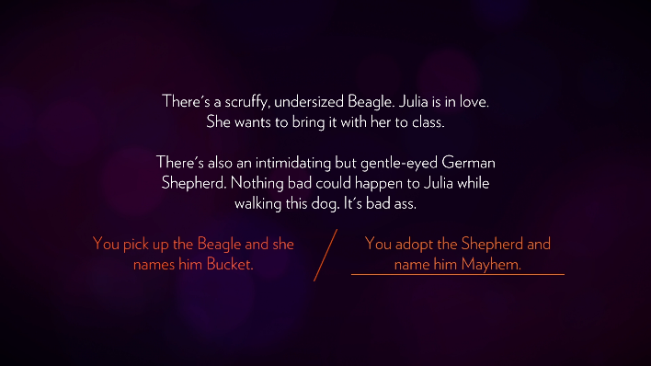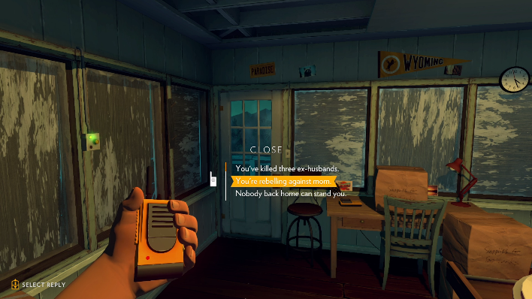The opening screen is impactful and hard hitting, it has a simple aesthetic but delivers an emotional response for the timing of when it is shown. The simple style with warm colours indicates a warming and relaxing game but the all black screen background contrasts, with connotations to a darker undertone to come.

Figure 2 - Optional Choices in Game

Figure 3 - Dialogue Options Over Radio

The game allows players to choose between dialogue options, but the story progresses the same, you will just unlock different dialogue options. However, the game allows for choosing routes in a variety of ways, one is through the radio where you have the option to choose between two to three options whereas shown in Figure 2, the user is deciding between two options. At some points it is the user selecting the one option, but this allows the user to feel more immersed in the game and become the character they are roleplaying as. It also provides a sense of dread and tension as if this pathway you were following was inevitable.

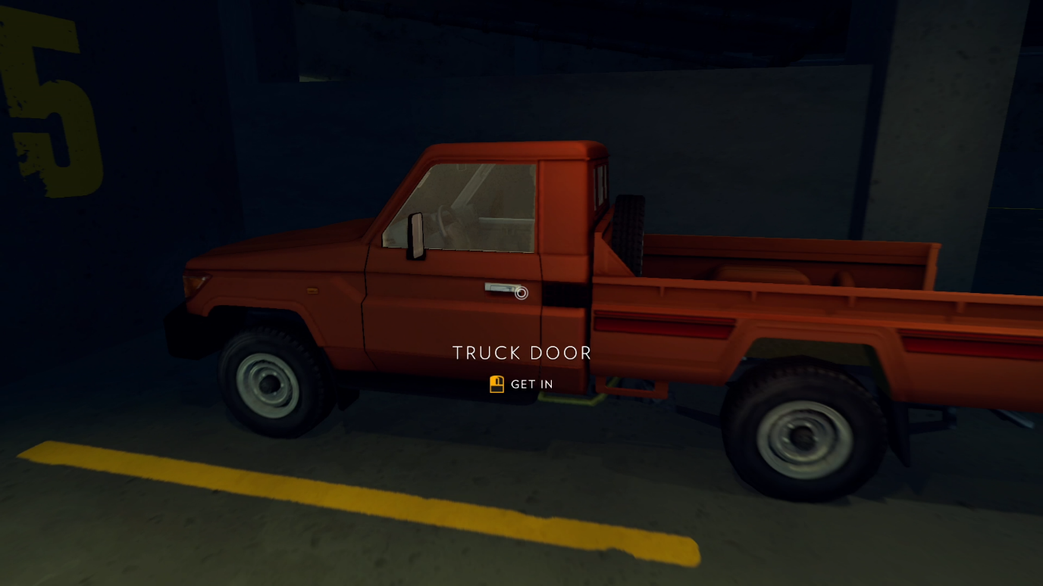

Figure 4 - Player Input Indicator

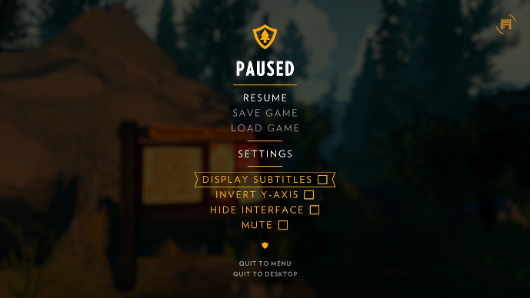Shown in Figure 4 is the option for the user to input a button or control to interact with the world. While this is necessary to progress the story, it is displayed to the user as a choice, giving the user a sense of freedom in an actual restricted space. It also familiarises the user with the buttons early on, so when they play later, the game will feel seamless and more natural, perhaps not needing the display options allowing for true immersion. This is an option the game provides. In Firewatch, the user can turn off the interface as seen in Figure 5, to truly get the full feel of the game.

Figure 5 - Pause Menu Interface

# Phoenix Wright: Ace Attorney Trilogy

Capcom (2012) *Phoenix Wright: Ace Attorney Trilogy.* [Video game]. Capcom. Available from: <https://www.xbox.com/en-gb/games/store/phoenix-wright-ace-attorney-trilogy/c4r4rb3sb1nn> [Accessed 04 March 2024].

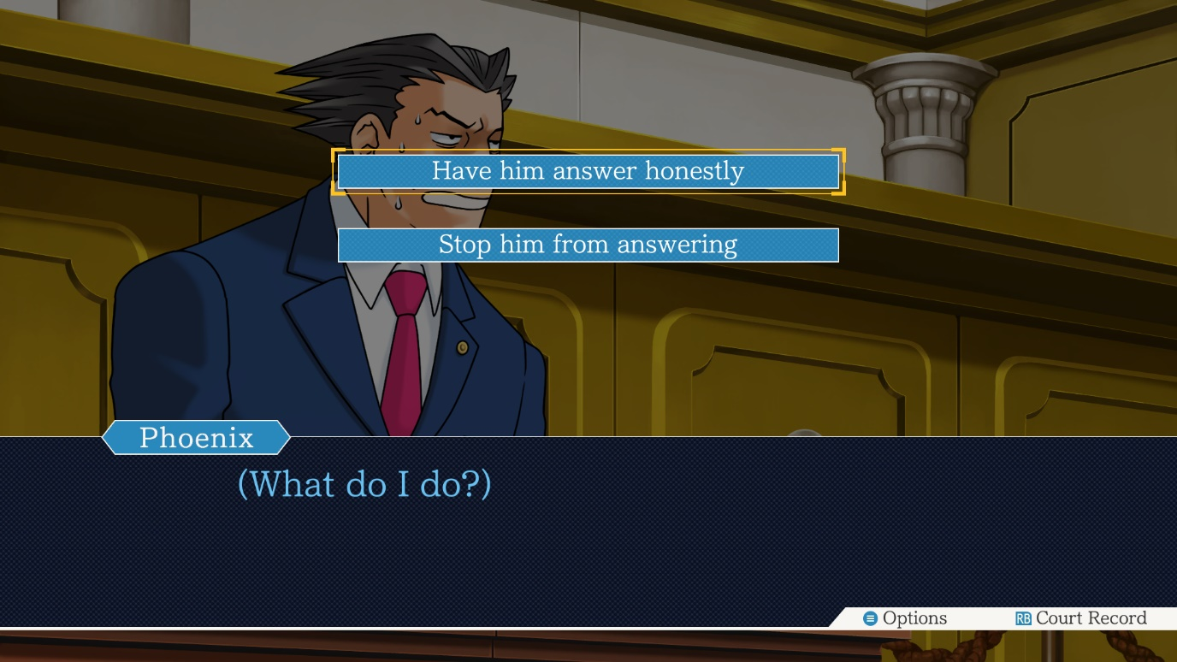

Figure 6 - Option Display and Dialogue

Phoenix Wright is a rather simple game with not many interactions, but it is heavily rich in dialogue which keeps the user’s attention. However, the interactive experiences it provides are critical to the function of the game. Since you play as an attorney any option that is incorrectly chosen can lead to a penalty from the game or failing the case. Therefore, this game follows a rather linear narrative with there only being one correct route, but the options enable users to feel rewarded by clicking the correct route.

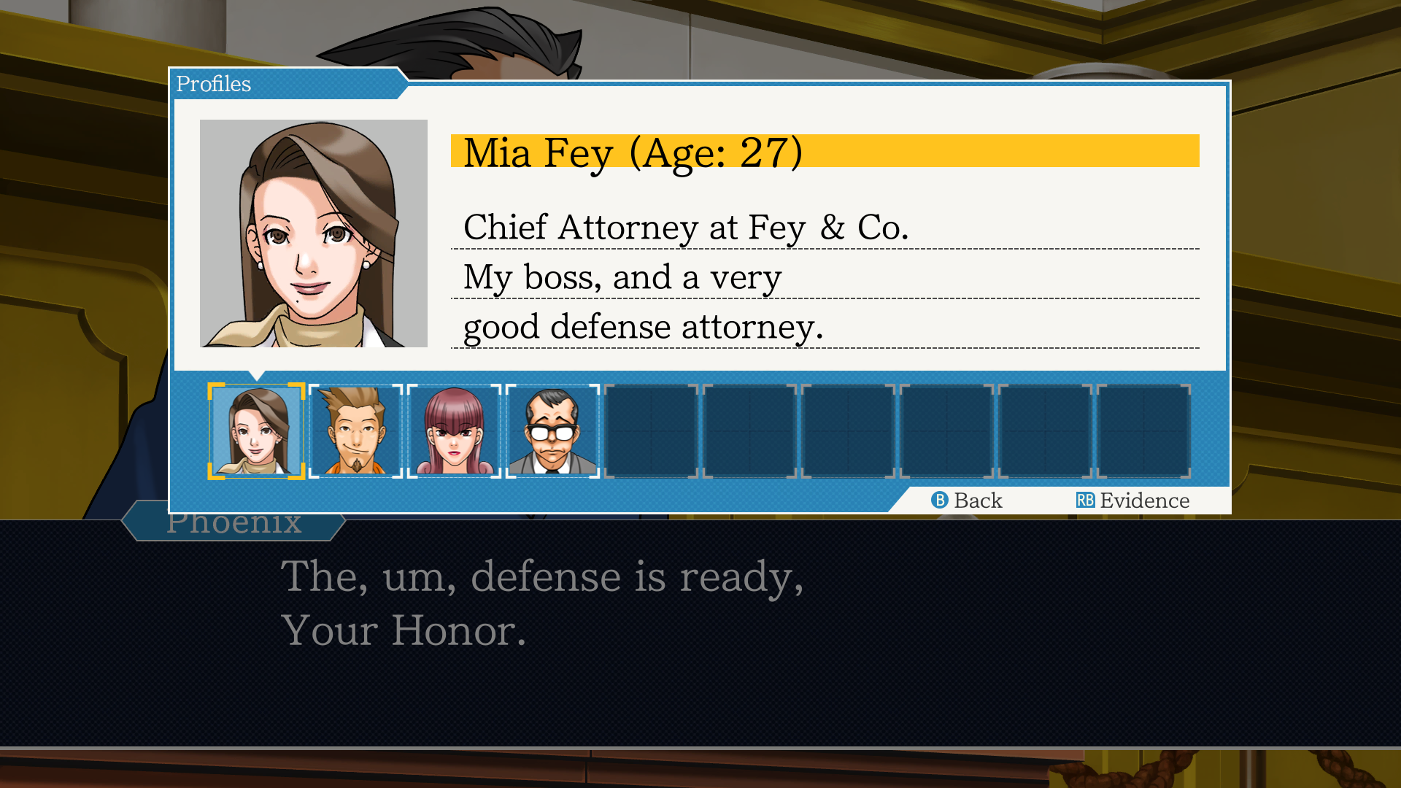

Figure 7 - Profiles and Evidence Menu

The other interface in the game enables the user to scroll through evidence in their hands as well as profiles of people involved in the case. This allows the user to object in between statements, which is another interactive experience and crucial to the game’s success.

# Walking Dead

Telltale Games (2012) *The Walking Dead.* [Video game]. Telltale Games. Available from: <https://www.xbox.com/en-gb/games/store/the-walking-dead-the-complete-first-season/bw6b077fch11> [Accessed 04 March 2024].

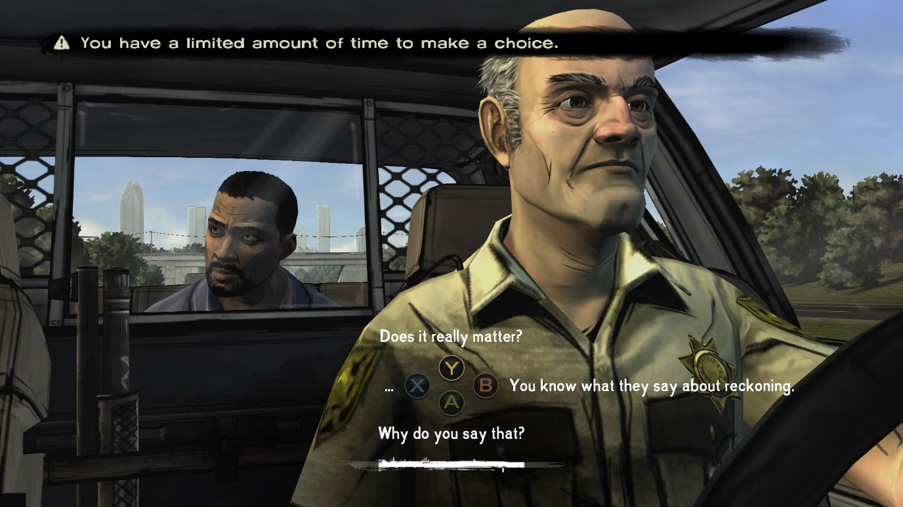

Figure 8 - Timed Dialogue Event

The walking dead takes a different approach to the dialogue options in the game, by having a countdown for users to select one. This timer is also played with further down the game by sometimes providing the user with a lot of time to make a decision or reducing it to a small window of time to make one. The game also assures users that at most points in time, they will not be punished for not making a decision, however it is clear in display that options and dialogue chosen can have consequences. For the most part the choices will not affect the story all that much, but the main branch choices can either remove a character in the game or provide a multitude of endings.

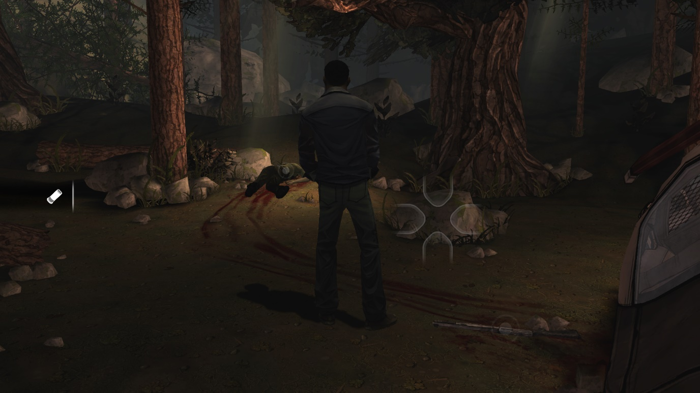

Figure 9 - Free Roam

The walking dead also allows users to explore the world they are in outside of the dialogue choices, involving small cutscenes/animation sequences but also free roam in certain segments. While there are a limited number of activities to do in these scenes which are highlighted through the circles over items as seen in Figure 9, these options allow immersion into the world and feel the terror and implications of their actions. The game also provides a four segment interface which the user controls with a mouse/controller and by pressing a button can activate events/interactions.

# VA-11 Hall-A

Sukeban Games (2016) *Va-11 Hall-A.* [Video game]. Ysbryd Games. Available from: <https://store.steampowered.com/app/447530/VA11_HallA_Cyberpunk_Bartender_Action/> [Accessed 04 March 2024].

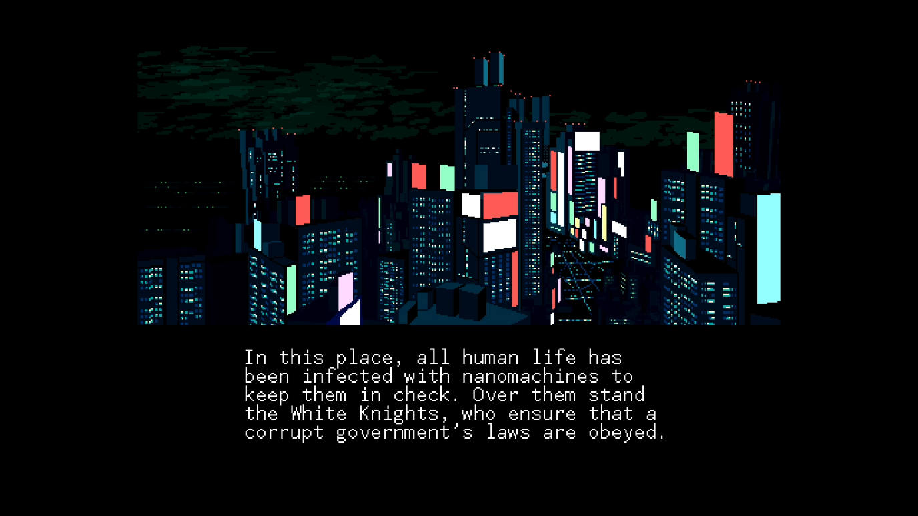

Figure 10 – Cutscene

Va-11 Hall-A starts with images and text displayed underneath to give the user background information before stepping into the world. This is a very basic form of interactive experiences. However, this quickly evolves into a more intricate HUD/Interface which the user will see for most of the game. This can be seen in Figure 11.

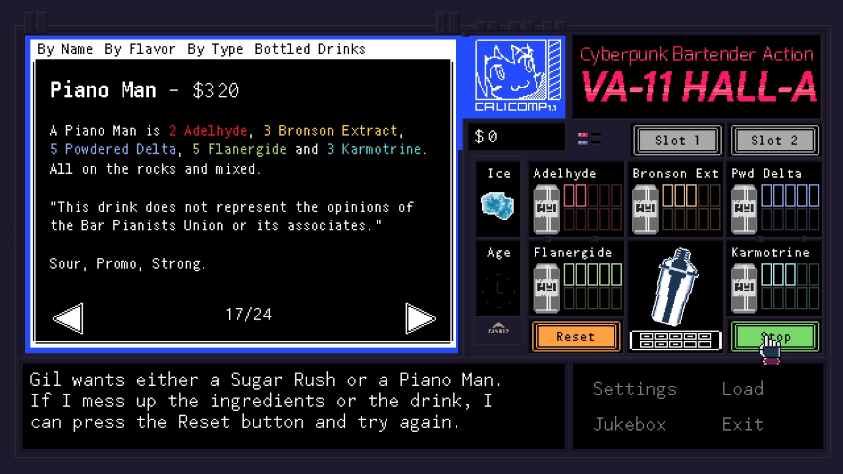

Figure 11 - Bar Interface

In the bottom left of the interface is where dialogue will be displayed to the user, and interestingly in this game, the user won’t be given the option to interact and select dialogue paths, these are instead unlocked through creating the desired drinks that the characters want. However, the game keeps the interaction interesting and challenging by making the orders more difficult or with characters asking, “for the usual” and the user is then encouraged to remember orders to progress the story and unlock most of the story as they can.

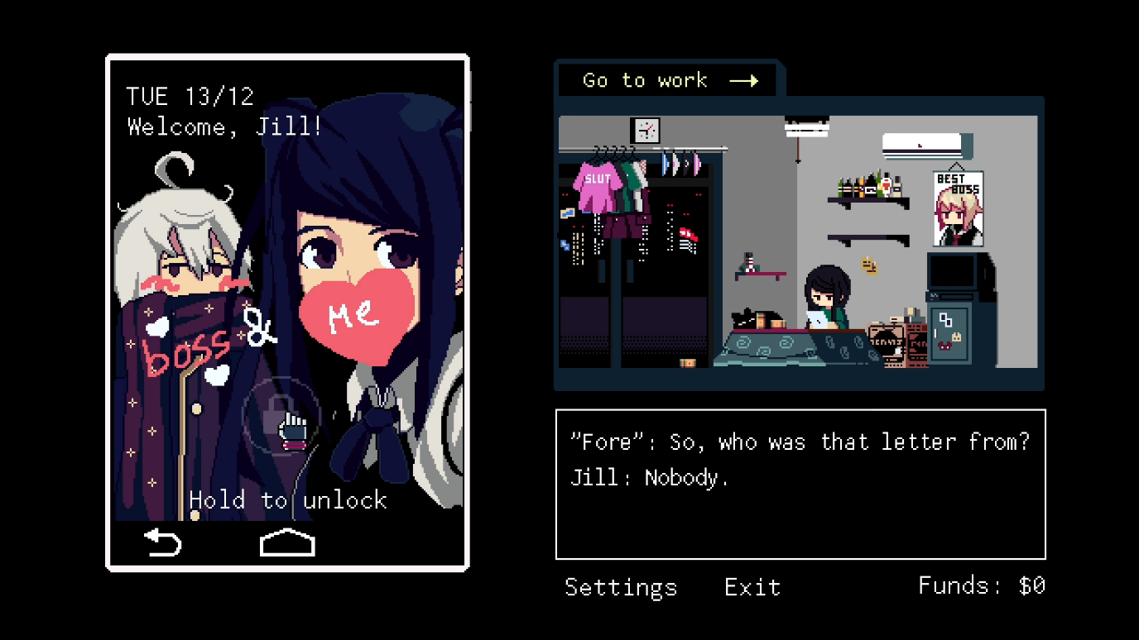

Figure 12 - Menu in-between Shifts

In between shifts, the user is also free to unlock more of the story by interacting with their phone and scrolling through it. This allows them to access the news as well as social media pages of people you have served in the past, enabling users to track their relationship with each NPC. From this they are aware of how much of someone’s story they have heard as well as keep up with the stories of NPCs who perhaps didn’t visit the bar that night.